01a Project Kickoff- Group Working Agreement

Group Number:  12 | Team Member Names
 | - Cole Campbell | - Kyle Cheon
 | - Jonah Botelho | - Nicholas Ng
 | - Abdullah Asmy

All group members agree to:

- Attend all Scrum ceremonies (stand-ups, sprint planning, sprint reviews, and retrospectives) and labs on time.
- Inform the team in advance if you will be missing a meeting and take responsibility for catching up on any decisions and discussions.
- Come to meetings with assigned tasks completed and necessary preparations made.
- Actively engage in backlog grooming and sprint planning to ensure clarity of goals.
- Report progress accurately during stand-ups and demonstrate work during sprint reviews.
- Commit to regular code check-ins to the team repository (e.g., GitHub/GitLab), with a minimum frequency of twice per week.
- Use designated communication tools (e.g., Slack, Discord) and respond to messages within 24 hours during weekdays.
- Contribute equitably to all tasks and activities, ensuring no one individual is overburdened.
- Actively contribute to discussions during sprint retrospectives, focusing on identifying lessons learned and opportunities for improvement.
- Participate actively and contribute equally to all team activities.
- Treat all team members with respect and adhere to the BCIT Student Code of Conduct

Additional ground rules (provide at least two):
- All code contributions must be approved by at least 1 other team member before merging to the respective branch.
- Raise bugs and issues when they arise rather than waiting until the next standup, and create a ticket to accompany it.

Team Communication
How will you handle communication during the project? Specify tools (e.g., Discord, Slack) and outline your communication frequency and protocols.

Discord

Daily communication every weekday, only sharing info relating to this project and communicating in the appropriate channels.

Success criteria: project and team
What will make this project a success for you?
Developing an MVP that we are proud of, and learning how to use new tools and languages.

What will make this team a successful team?
If we all feel like we have contributed equally to the project, and we had fun in the process.

Decision-making procedure and accountability
What will be our decision-making process?
We will use agile practices, along with standups three times a week, where we will review our work, discuss any ideas that come up, and decide on the next step in our iterative development.

Each members general team role:
Cole: Owner of all submission documents, leader of team scrums
Jonah: Trello board master, main task tracker
Kyle: Transcriber for meetings, general frontend integration
Nick: Owner of repository, general backend integration
Abdullah: UI/UX design

What decisions need all group members to agree?
Selection of tools/languages to use, design aspects of the codebase, questions to ask our client.

How will we hold people accountable for the work set?
Regular task tracking using our Trello board which will be reviewed weekly.

If any member of the project team repeatedly fails to meet these ground rules, the other members of the group are expected to take the following actions:

Step 1: Raise the issue directly and respectfully in a team meeting and thoroughly record all decisions, actions, and owners in the team Meeting Minutes document. If not resolved:

Step 2: Raise the issue as a group, directly, respectfully, and honestly during the Supervisor meeting and thoroughly record all decisions, actions, and owners in the Supervisor Meeting Minutes document. If not resolved:

Step 3: Meet as a group with the course instructor.

The teaching team (your Supervisor and the course instructor) reserves the right to make the final decision(s) to resolve difficulties that arise within the groups. Before this becomes necessary, the team should try to find a fair and equitable solution to the problem.

Team Member’s Signatures:
We, the undersigned, agree to abide by the ground rules outlined above:
- Name: Cole Campbell Signature: 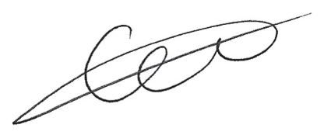
- Name: Abdullah Asmy Signature: A.A.
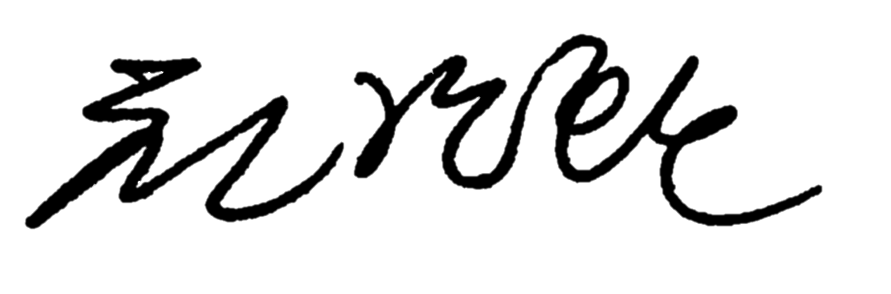
- Name: Nicholas Ng Signature: N.N
- Name: Kyle Cheon Signature:
- Name: Jonah Botelho Signature: 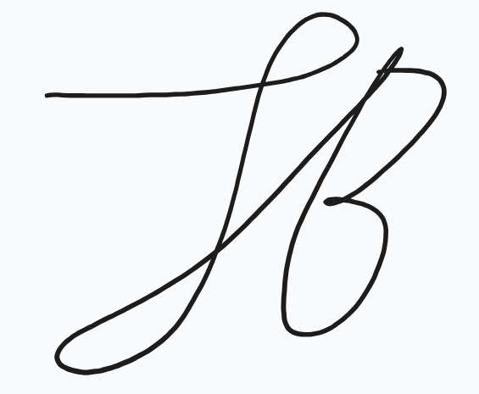
Date: May 1, 2026

